EXPERIMENT – 9

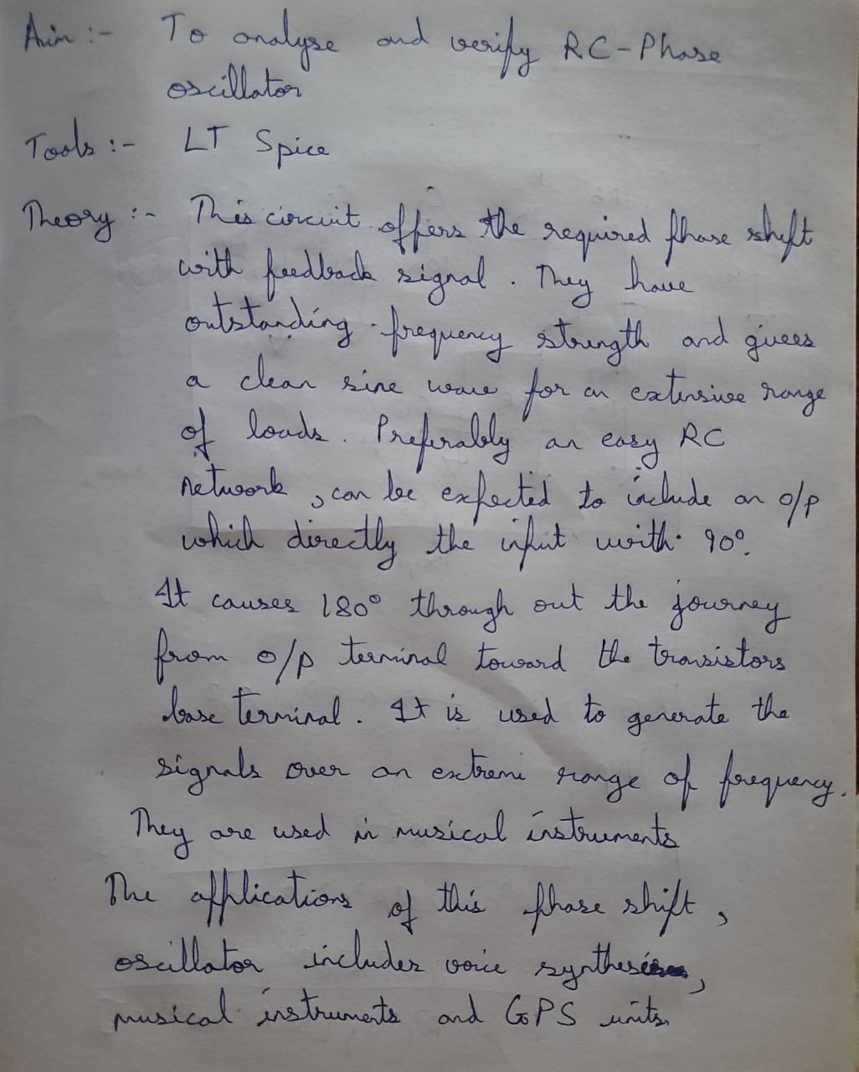

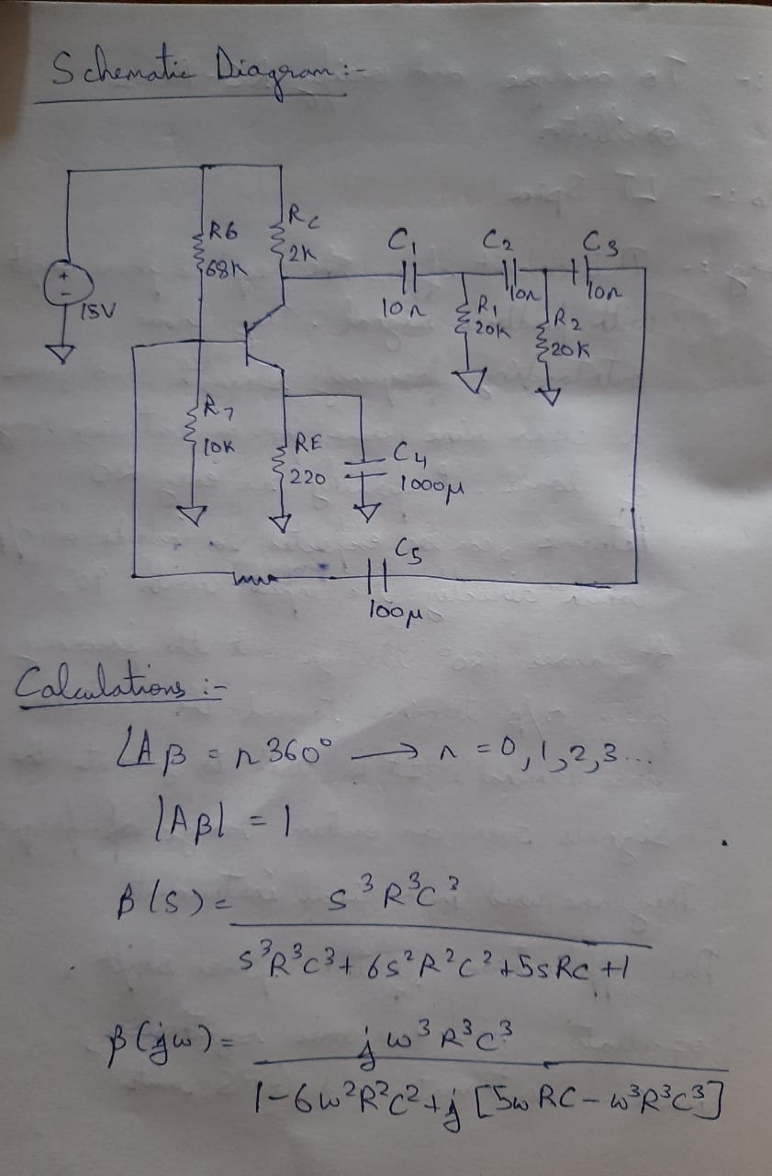

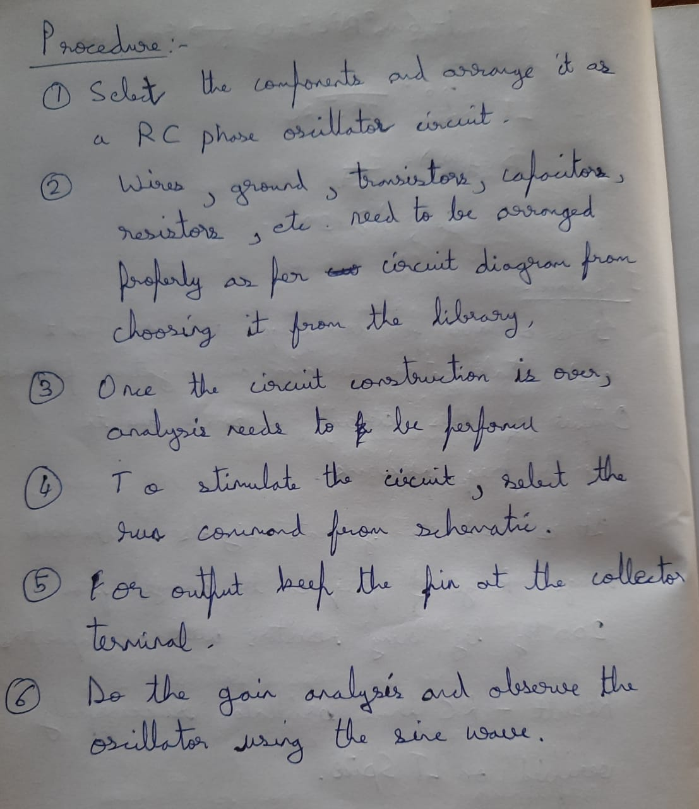

SCHEMATIC DIAGRAM:

OUTPUT:

